**CDAC Mumbai PG-DAC August 24**

**Module 2 OOPJ**

**Assignment No- 5**

1. Create a base class BankAccount with methods like deposit() and withdraw(). Derive a class SavingsAccount that overrides the withdraw() method to impose a limit on the withdrawal amount. Write a program that demonstrates the use of overridden methods and proper access modifiers & return the details.

Program:

**package** org.inheritance.bankQ1;

**public** **class** BankAccount {

String accountNumber;

**double** accountBalnce;

**public** BankAccount(String accountNumber, **double** accountBalnce) {

**this**.accountNumber = accountNumber;

**this**.accountBalnce = accountBalnce;

}

**public** String getAccountNumber() {

**return** accountNumber;

}

**public** **double** getAccountBalnce() {

**return** accountBalnce;

}

**public** **void** setAccountNumber(String accountNumber) {

**this**.accountNumber = accountNumber;

}

**public** **void** setAccountBalnce(**double** accountBalnce) {

**this**.accountBalnce = accountBalnce;

}

**public** **void** deposite(**double** amount) {

**this**.accountBalnce=accountBalnce+amount;

}

**public** **void** withdraw(**double** amount) {

**if** (amount <= **this**.accountBalnce) {

**this**.accountBalnce=accountBalnce-amount;

}**else** {

System.***out***.println("Insufficient Funds");

}

}

}

**package** org.inheritance.bankQ1;

**public** **class** SavingAccount **extends** BankAccount {

**private** **static** **final** **double** ***min_balance*** =100.00;

**public** SavingAccount(String accountNumber, **double** accountBalnce) {

**super**(accountNumber, accountBalnce);

}

@Override

**public** **void** withdraw(**double** amount) {

**if** (accountBalnce-amount <***min_balance***) {

System.***out***.println("Transaction Failed- Minimum Balance "+***min_balance***+" is Required" );

}**else** {

**super**.withdraw(amount);

}

}

}

**package** org.inheritance.bankQ1;

**public** **class** Test {

**public** **static** **void** main(String[] args) {

BankAccount b1 = **new** BankAccount("12345", 1000);

System.***out***.println("Account Succefully Created with Details :\nAccount Number= " + b1.getAccountNumber()

+ "\nAccount Balance= " + b1.getAccountBalnce());

b1.deposite(1000);

System.***out***.println("Amount Deposited Succesfully :Current Balance is: " + b1.getAccountBalnce());

b1.withdraw(2000);

System.***out***.println("Amount Withdraw Succesfully :Current Balance is: " + b1.getAccountBalnce());

SavingAccount s1 = **new** SavingAccount("100011", 1000);

System.***out***.println("Account Succefully Created with Details :\nAccount Number= " + s1.getAccountNumber()

+ "\nAccount Balance= " + s1.getAccountBalnce());

s1.deposite(1000);

System.***out***.println("Amount Deposited Succesfully :Current Balance is: " + s1.getAccountBalnce());

s1.withdraw(2000);

System.***out***.println("Amount Withdraw Succesfully :Current Balance is: " + s1.getAccountBalnce());

}

}

Output:

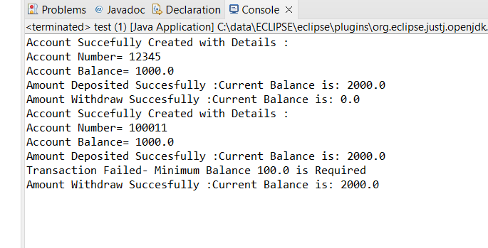

1. Create a base class Vehicle with attributes like make and year. Provide a constructor in Vehicle to initialize these attributes. Derive a class Car that has an additional attribute model and write a constructor that initializes make, year, and model. Write a program to create a Car object and display its details.

Program:

**package** org.inheritance.vehicleQ2;

**public** **class** Vehicle {

**private** String make;

**private** **int** year;

**public** Vehicle(String make, **int** year) {

**this**.make = make;

**this**.year = year;

}

**public** String getMake() {

**return** make;

}

**public** **void** setMake(String make) {

**this**.make = make;

}

**public** **int** getYear() {

**return** year;

}

**public** **void** setYear(**int** year) {

**this**.year = year;

}

@Override

**public** String toString() {

**return** String.*format*("Vehicle Info \nmake=%s \nyear=%s", make, year);

}

}

**package** org.inheritance.vehicleQ2;

**public** **class** Car **extends** Vehicle{

**private** String Model;

**public** Car(String make, **int** year, String model) {

**super**(make, year);

Model = model;

}

**public** String getModel() {

**return** Model;

}

**public** **void** setModel(String model) {

Model = model;

}

@Override

**public** String toString() {

**return** **super**.toString()+ "\nCar Model="+ **this**.getModel();

}

}

**package** org.inheritance.vehicleQ2;

**public** **class** test {

**public** **static** **void** main(String[] args) {

Vehicle v = **new** Vehicle("Mahindra", 2022);

System.***out***.println(v.toString());

Car c = **new** Car("Mahindra", 2022, "Scorpio");

System.***out***.println(c.toString());

}

}

Output:

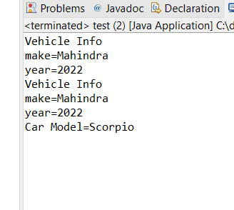

1. Create a base class Animal with attributes like name, and methods like eat() and sleep(). Create a subclass Dog that inherits from Animal and has an additional method bark(). Write a program to demonstrate the use of inheritance by creating objects of Animal and Dog and calling their methods.

**package** org.inheritance.AnimalQ3;

**public** **class** Animal {

**private** String Name;

**public** Animal(String name) {

Name = name;

}

**public** **void** eat() {

System.***out***.println(Name + " is Eating.");

}

**public** **void** sleep() {

System.***out***.println(Name + " is Sleeping");

}

}

**package** org.inheritance.AnimalQ3;

**public** **class** Dog **extends** Animal {

**private** String Name;

**public** Dog(String name) {

**super**(name);

**this**.Name = name;

}

**public** **void** bark() {

System.***out***.println(Name + " is Barking");

}

}

**package** org.inheritance.AnimalQ3;

**public** **class** test {

**public** **static** **void** main(String[] args) {

Animal A = **new** Animal("Cow");

A.eat();

A.sleep();

Dog D = **new** Dog("Pandu");

D.eat();

D.sleep();

D.bark();

}

}

Output;

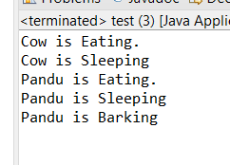

1. Build a class Student which contains details about the Student and compile and run its instance.

**package** org.inheritance.StudentqQ4;

**public** **class** Students {

String Name;

**int** rollNo;

**int** age;

String Course;

**public** Students() {

**this**("", 0, 0, "");

}

**public** Students(String name, **int** rollNo, **int** age, String course) {

Name = name;

**this**.rollNo = rollNo;

**this**.age = age;

Course = course;

}

**public** String getName() {

**return** Name;

}

**public** **void** setName(String name) {

Name = name;

}

**public** **int** getRollNo() {

**return** rollNo;

}

**public** **void** setRollNo(**int** rollNo) {

**this**.rollNo = rollNo;

}

**public** **int** getAge() {

**return** age;

}

**public** **void** setAge(**int** age) {

**this**.age = age;

}

**public** String getCourse() {

**return** Course;

}

**public** **void** setCourse(String course) {

Course = course;

}

@Override

**public** String toString() {

**return** String.*format*("Students Details : \nName= %s \nrollNo= %s \nage= %s \nCourse= %s", Name,

rollNo, age, Course);

}

}

**package** org.inheritance.StudentqQ4;

**import** java.util.Scanner;

**public** **class** StudentTest {

**private** **static** Scanner *sc* = **new** Scanner(System.***in***);

**public** **static** **void** main(String[] args) {

Students students = **new** Students();

System.***out***.print("Name:");

students.setName(*sc*.nextLine());

System.***out***.print("Roll No:");

students.setRollNo(*sc*.nextInt());

System.***out***.print("Age:");

students.setAge(*sc*.nextInt());

*sc*.nextLine();

System.***out***.print("Course:");

students.setCourse(*sc*.nextLine());

*sc*.close();

System.***out***.println(students.toString());

}

}

Output:

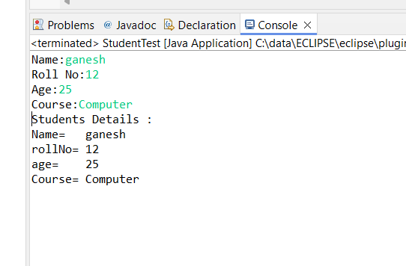

1. Write a Java program to create a base class Vehicle with methods startEngine() and stopEngine(). Create two subclasses Car and Motorcycle. Override the startEngine() and stopEngine() methods in each subclass to start and stop the engines differently.

**package** org.inheritance.EngineQ5;

**public** **class** Vehicle {

**public** **void** startEngine() {

}

**public** **void** stopEngine() {

}

}

**package** org.inheritance.EngineQ5;

**public** **class** Car **extends** Vehicle {

@Override

**public** **void** startEngine() {

System.***out***.println("Car Engine Started");

}

@Override

**public** **void** stopEngine() {

System.***out***.println("Car Engine Stopped");

}

}

**package** org.inheritance.EngineQ5;

**public** **class** Motorcycle **extends** Vehicle {

@Override

**public** **void** startEngine() {

System.***out***.println("MotorCycle Engine Started");

}

@Override

**public** **void** stopEngine() {

System.***out***.println("MotorCycle Engine Stopped");

}

}

**package** org.inheritance.EngineQ5;

**public** **class** Test {

**public** **static** **void** main(String[] args) {

Vehicle car = **new** Car();

car.startEngine();

car.stopEngine();

Vehicle motorcycle = **new** Motorcycle();

motorcycle.startEngine();

motorcycle.stopEngine();

}

}

Output:

